**IMPLEMENTATION OF PLANT DISEASE IDENTIFICATION USING ADVANCED DEEP LEARNING**

**A MINOR PROJECT SYNOPSIS**

***Submitted in partial fulfillment of th*e *requirements for the award of the degree***

***Of***

**BACHELOR OF TECHNOLOGY**

***In***

**ELECTRONICS & COMMUNICATION ENGINEERING**

***By***

**BHAVYA MISHRA**

**F4**

**03815602821**

**+91-8287833957**

***Guided by***

**Mr. Devraj Gautam, Assistant Professor, ECE Department**



**Department of Electronics & Communication Engineering**

**DR. AKHILESH DAS GUPTA INSTITUTE OF PROFESSIONAL STUDIES**

**(AFFILIATED TO GURU GOBIND SINGH INDRAPRASTHA UNIVERSITY)**

**NEW DELHI – 110053**

**August- 2024**

**CONTENTS**

|  |  |  |
| --- | --- | --- |
| **S.No.** | **Table of Contents** | **Page No.** |
| **i.** | Introduction | 3 |
| **ii.** | Objective & Block Diagram | 3 - 5 |
| **iii.** | Methodology & Tools Used | 5 – 6 |
| **iv.** | Advantages & Application | 7 - 9 |
| **v.** | Major Problems | 10 |
| **vi.** | Future Scope | 11 |
| **vii.** | References & Related Research Paper | 12 |

**INTRODUCTION**

In recent years, deep learning has revolutionized the field of agriculture by offering powerful tools for plant disease identification. Traditional methods of disease detection, which rely on manual observation, are often time-consuming, labor-intensive, and prone to human error. By applying deep learning techniques, specifically Convolutional Neural Networks (CNNs), it's possible to automatically and accurately identify diseases from images of plant leaves or other affected parts. These models can analyze complex patterns in the data, enabling farmers and agricultural professionals to diagnose plant diseases quickly and with high precision, leading to timely interventions and improved crop yields.

The integration of deep learning into plant disease identification not only enhances the accuracy and speed of diagnosis but also makes advanced agricultural technology more accessible. This approach supports large-scale monitoring and can be deployed in various environments, from individual farms to extensive agricultural regions, helping to mitigate crop losses and promote sustainable farming practices.

**OBJECTIVE**

This paper will have the following contributions to the society:

* This paper presents an overview of recent advances in plant disease detection and classification using ML and DL approaches. Accordingly, it provides an in-depth review of the state-of-the-art techniques and methodologies used in the area by covering research published in the field.
* The paper shows how using ML and DL approaches improves the performance and speed of plant disease detection and classification.
* Identifying the best DL technique for multi-class plant disease detection and classification and optimal identification accuracy.
* The development of DL techniques for detecting and classifying numerous plant diseases;
* Addressing the different labelling and class challenges in recognizing plant diseases by recommending multi-class, multi-label DL techniques.
* The use of a new technique with different steps designed to improve plant disease detection and classification in real-world images yields quick results and is suited for real-time applications.

**BLOCK DIAGRAM**

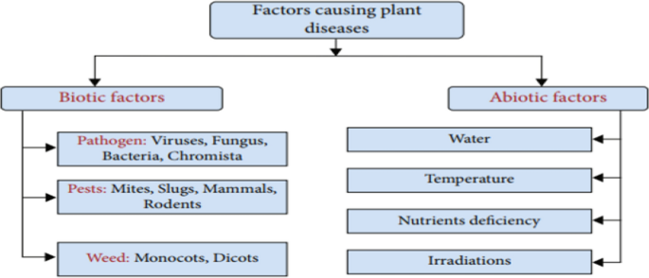

Fig1: Factors causing plant diseases

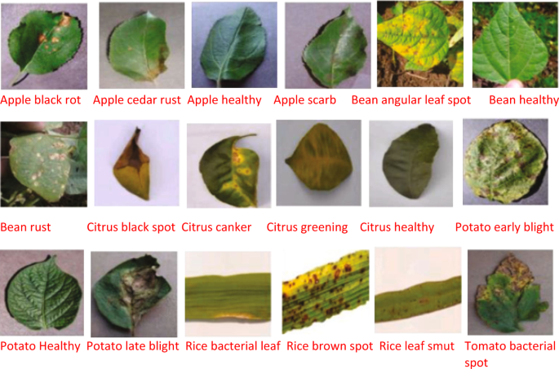

Fig2: Some sample plant leaf images with different diseases.

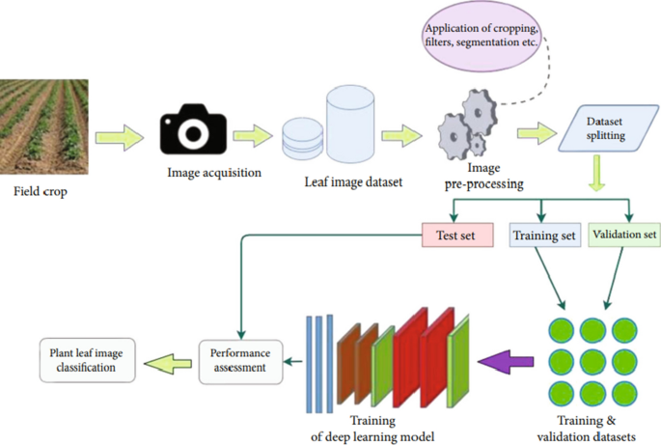

Fig3: Computer vision-based techniques for plant disease detection and classification

**METHODOLOGY**

1. **Data Collection and Pre-processing:**

* **Image Acquisition:** Collect images of plants with and without diseases. These images can be obtained from public datasets, field surveys, or lab-controlled environments.
* **Data Augmentation:** Techniques like rotation, flipping, scaling, and colour adjustments are applied to increase the diversity of the dataset and improve model generalization.

1. **Feature Extraction:**

* **Traditional Image Processing:** Techniques like colour space transformation, edge detection, texture analysis (using GLCM, LBP), and morphological operations.
* **Deep Learning-based Feature Extraction:** Use Convolutional Neural Networks (CNNs) to automatically learn and extract features from images.

1. **Model Development:**

* **Classification Models:** Use models like CNNs, Transfer Learning models (e.g., VGG16, Res-Net, Inception), or traditional classifiers (e.g., SVM, Random Forest) with extracted features to classify the images into healthy or diseased categories.
* **Segmentation Models:** U-Net, Mask R-CNN, and other segmentation models can be used if the goal is to identify and segment diseased areas in the images.

1. **Training and Evaluation:**

* **Training:** The model is trained on the labelled dataset using techniques like cross-validation, data augmentation, and hyperparameter tuning.
* **Evaluation:** Performance metrics like accuracy, precision, recall, F1-score, and confusion matrix are used to evaluate the model. Visualization tools like ROC curves may also be employed.

1. **Deployment:**

* **Model Export:** The trained model is saved using formats like TensorFlow Saved Model, PyTorch model files, or ONNX for deployment.
* **Web/Mobile Application:** Flask, Django, or mobile frameworks (e.g., TensorFlow Lite) are used to create interfaces for users to upload plant images and receive disease predictions.

1. **Post-deployment Monitoring:**

* **Model Monitoring:** Continuous monitoring of model performance in real-world usage to detect and correct any drift in model predictions.
* **Updates and Retraining:** Regular updates to the model with new data to ensure it stays accurate and relevant.

**ADVANTAGES & APPLICATIONS**

**Advantages:**

**Early Detection:**

* **Prevent Crop Loss:** Early identification of diseases allows for timely intervention, reducing the risk of widespread damage and potentially saving entire crops.
* **Minimized Pesticide Use:** By identifying specific diseases, farmers can apply targeted treatments rather than broad-spectrum pesticides, reducing chemical usage and environmental impact.

**Increased Agricultural Productivity:**

* **Optimized Yield:** Healthy crops lead to better yields, enhancing food production and contributing to food security.
* **Cost Efficiency:** Automated disease detection reduces the need for frequent manual inspections, lowering labour costs and enabling more efficient resource allocation.

**Scalability:**

* **Large-Scale Monitoring:** The system can be scaled to monitor vast agricultural lands, making it feasible to manage large-scale farms more effectively.
* **Real-time Analysis:** With proper deployment, the system can provide real-time analysis, enabling immediate action against detected diseases.

**Accessibility:**

* **Low-Cost Solutions:** Using smartphones or affordable cameras, farmers can access advanced disease detection technologies without the need for expensive equipment.
* **Remote Monitoring:** Enables farmers to monitor crops remotely, which is especially beneficial for those managing multiple farms or large agricultural areas.

**Data-Driven Insights:**

* **Trend Analysis:** Continuous monitoring and data collection allow for trend analysis, helping in predicting potential disease outbreaks based on historical data.
* **Decision Support:** Provides actionable insights that can guide farmers in making informed decisions about crop management, planting schedules, and treatment strategies.

**Sustainability:**

* **Environmental Protection:** Targeted treatment and reduced pesticide use contribute to sustainable farming practices, protecting the environment and biodiversity.
* **Resource Optimization:** Helps in optimizing the use of water, fertilizers, and other inputs, leading to more sustainable agricultural practices.

**Applications:**

**Precision Agriculture:**

* **Targeted Treatment:** Apply specific treatments only where needed, reducing waste and improving the overall health of the crops.
* **Variable Rate Application:** Integrate with automated machinery to apply the right amount of pesticides or fertilizers based on the disease intensity detected.

**Farm Management Systems:**

* **Integration with IoT:** Combine disease identification with IoT devices like drones and sensors to automate farm monitoring and management.
* **Automated Reporting:** Generate reports on crop health, disease prevalence, and recommended actions, aiding in decision-making for farm managers.

**Agricultural Advisory Services:**

* **Support for Farmers:** Extension services can use this technology to provide farmers with timely advice on disease management, helping to improve crop outcomes.
* **Training and Education:** Educate farmers about disease identification and management, enhancing their knowledge and ability to manage crops effectively.

**Research and Development:**

* **Agronomy Research:** Assist in studying disease patterns, plant resistance, and the effectiveness of different treatment methods.
* **Breeding Programs:** Use disease identification data to support breeding programs aimed at developing disease-resistant plant varieties.

**Supply Chain Management:**

* **Quality Control:** Ensure that only healthy crops enter the supply chain, improving the quality of produce reaching consumers.
* **Traceability:** Track disease outbreaks and affected batches, aiding in traceability and recall efforts if necessary.

**Urban and Community Farming:**

* **Support for Small-Scale Farmers:** Provide disease identification tools to urban and small-scale farmers who may not have access to traditional agricultural support.
* **Community Gardens:** Help community gardens maintain healthy plants, promoting food security and sustainability in urban areas.

**Educational Tools:**

* **Agricultural Education:** Use as a teaching tool in agricultural education programs, helping students learn about plant diseases, their impact, and modern solutions.
* **Public Awareness:** Increase public awareness of plant diseases and the importance of healthy crops, promoting more informed consumer choices.

**MAJOR PROBLEMS**

**Data Availability and Quality:**

* **Limited Datasets:** High-quality, labelled datasets specific to certain crops or regions might be scarce, limiting the effectiveness of the models.
* **Image Variability:** Variations in lighting, background, and image quality can impact the accuracy of the disease detection model.

**Model Generalization:**

* **Overfitting:** Models trained on specific datasets may not generalize well to new, unseen data, particularly when dealing with diverse environmental conditions.
* **Species and Disease Variability:** Different plant species may exhibit similar symptoms for different diseases, making it challenging for models to differentiate between them.

**Real-Time and On-Field Implementation:**

* **Hardware Limitations:** Implementing real-time disease identification on portable devices like smartphones or drones may face challenges due to limited computational power and battery life.
* **Scalability:** Scaling the system to large farms or diverse regions requires significant computational resources and robust infrastructure.

**Interoperability:**

* **Integration with Existing Systems:** Integrating disease identification systems with existing farm management software and IoT devices can be complex and may require customized solutions.
* **Standardization:** Lack of standardized protocols for data collection, processing, and reporting can lead to inconsistencies and challenges in system interoperability.

**FUTURE SCOPE**

**Integration with IoT and Remote Sensing:**

* **IoT-Driven Monitoring:** Combining disease identification with IoT sensors for real-time monitoring of environmental conditions, allowing for more comprehensive plant health assessments.
* **Drones and Satellite Imagery:** Utilizing drones and satellite imagery to detect diseases on a large scale, covering vast agricultural areas with high precision.

**Personalized Solutions:**

* **Localized Models:** Developing models that are customized for specific regions, taking into account local environmental factors and prevalent diseases.
* **Adaptive Learning Systems:** Implementing models that can continuously learn from new data, adapting to changing conditions and new disease variants.

**Sustainability and Climate Resilience:**

* **Climate-Responsive Models:** Creating models that account for changing climate conditions, helping farmers adapt to and mitigate the impact of climate change on crop health.
* **Sustainable Farming Practices:** Integrating disease identification with sustainable farming practices, promoting organic farming, and reducing the environmental impact of agriculture.

**Global Accessibility and Scalability:**

* **Mobile Applications:** Developing lightweight mobile applications that can run on low-cost smartphones, making disease identification accessible to farmers in developing countries.
* **Cloud-Based Solutions:** Offering cloud-based platforms that provide scalable disease identification services, enabling small farmers to benefit from advanced technologies without heavy investments in infrastructure.

**REFERENCES & RESEARCH PAPERS**

1. Tirkey D, Singh KK, Tripathi S. Performance analysis of AI-based solutions for crop disease identification detection, and classification. Smart Agric Technol. 2023. <https://doi.org/10.1016/j.atech.2023.100238>.
2. Ramanjot, et al. Plant disease detection and classification: a systematic literature review”. Sensors. 2023. <https://doi.org/10.3390/s23104769>.
3. Krishnan VG, Deepa J, Rao PV, Divya V, Kaviarasan S. An automated segmentation and classification model for banana leaf disease detection. J Appl Biol Biotechnol. 2022;10(1):213–20. <https://doi.org/10.7324/JABB.2021.100126>.
4. S Mathulaprangsan K Lanthong S Patarapuwadol. 2020. Rice Diseases Recognition Using Effective Deep Learning Models. Telecommun. Eng Media Technol with ECTI North Sect Conf Electr Electron Jt Int Conf Digit Arts Comput. <https://doi.org/10.1109/ECTIDAMTNCON48261.2020.9090709>
5. Heltin Genitha C, Dhinesh E, Jagan A. Detection of leaf disease using principal component analysis and linear support vector machine. Adv Comput ICoAC Proc Int Conf. 2019. <https://doi.org/10.1109/ICoAC48765.2019.246866>.
6. P. S. Gupta, P. Hans, and S. Chand. 2020. Classification Of Plant Leaf Diseases Using Machine Learning And Image Preprocessing Techniques.
7. S. V. Militante, B. D. Gerardo, and N. V. Dionisio, “Plant Leaf Detection and Disease Recognition using Deep Learning,” 2019 IEEE Eurasia Conf. IOT, Commun. Eng., pp. 579–582, 2019.
8. Sardogan M, Tuncer A, Ozen Y. Plant leaf disease detection and classification based on CNN with LVQ algorithm. Comput Sci Eng Conf. 2018. <https://doi.org/10.1109/UBMK.2018.8566635>.
9. Sharma M, Kumar CJ, Deka A. Early diagnosis of rice plant disease using machine learning techniques. Arch Phytopathol Plant Prot. 2022;55(3):259–83. <https://doi.org/10.1080/03235408.2021.2015866>.
10. Sharath DM, Akhilesh S, Kumar A, Rohan MG, Prathap C. Image based plant disease detection in pomegranate plant for bacterial blight. Proc IEEE Int Conf Commun Signal Process ICCSP. 2019. <https://doi.org/10.1109/ICCSP.2019.8698007>.